Report

Team ID | MCA
Project Name | Smartphone Usage, Digital Addiction & Well-Being Analytics
Maximum Marks | 5 Marks

A report is a comprehensive document that provides a detailed and structured account of data analysis, findings, and insights. It is typically used for in-depth analysis, documentation, and communication of results. Reports are suitable for a diverse audience, including decision-makers, analysts, and stakeholders who need a comprehensive understanding of the data.
Designing a report in Power BI involves connecting to data sources, creating visualizations like charts and graphs, customizing their appearance and interactivity, organizing them logically on the canvas, formatting elements for consistency and clarity, and optionally creating dashboards for a summarized view. Throughout the process, it's essential to consider the audience's needs and ensure the report effectively communicates insights from the data. Finally, iterate based on feedback to continually improve the report's design and usefulness.

Part 1: Digital Addiction & Screen Time Metrics

Key Performance Indicators (KPIs):
- Average App Opens: 97.83 apps opened per day.
- Average Social Media Hours: 3.27 hours spent on social media daily.
- Average Daily Notifications: 134.26 notifications received per day.

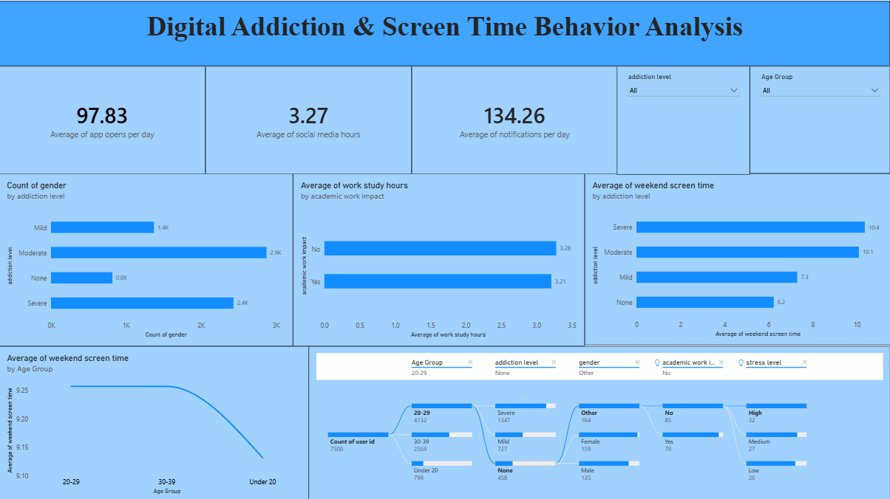

Observations and Analytical Insights:
- Trends Over Time & Age Group Analysis: Weekend screen time shows a notable downward trend as user age increases. Users in the 20–29 age bracket register the highest average weekend screen time (approximately 9.25 hours), which gradually slopes downwards toward the 30–39 and Under 20 categories.
- Addiction Levels vs. Gender Count: A breakdown of gender count by addiction severity shows that the Moderate addiction category contains the highest user volume at 2.9K users, closely followed by the Severe category at 2.4K users. Mild levels account for 1.4K, while None stands at 0.8K.
- Weekend Screen Time Impact: Those with a Severe addiction level report the highest average weekend screen time at 10.4 hours, compared to 10.1 hours for Moderate, 7.3 hours for Mild, and 6.2 hours for those with no addiction.
- Academic & Work Balance: When reviewing the average work/study hours by academic work impact, the metrics remain relatively stable. Users reporting No academic impact average 3.28 hours of work/study, while those answering Yes to academic impact maintain an average of 3.21 hours.

Part 2: Smartphone Addiction & Digital Well-Being Insights

Key Performance Indicators (KPIs):
  - Average Gaming Hours: 2.01 hours spent gaming.
  - Average Age of Users: 26.57 years old.
  - Average Work/Study Hours: 3.24 hours.

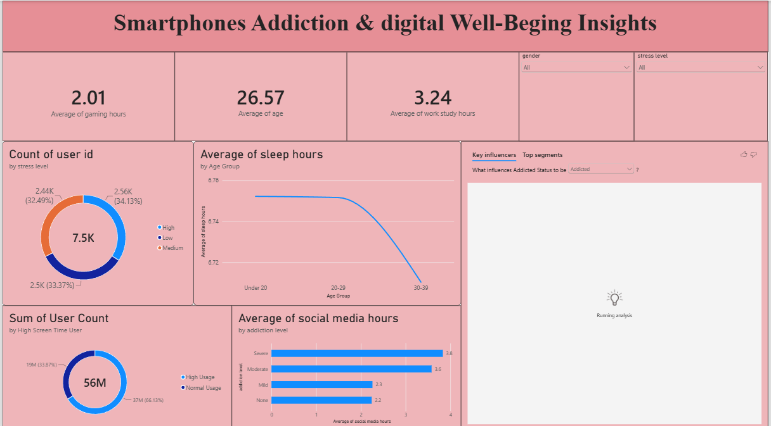

Observations and Analytical Insights:
- Sleep Hours and Aging: There is a distinct drop in sleep duration tied to age. The Under 20 age cohort achieves the highest average sleep at roughly 6.76 hours, which slightly plateaus for the 20–29 demographic before dropping sharply for users aged 30–39 to below 6.72 hours.
- Stress Level Breakdown: Out of 7.5K total tracked users, the distribution across stress levels is highly balanced: Low Stress accounts for 2.56K (34.13%), Medium Stress is 2.5K (33.37%), and High Stress is
2.44K (32.49%).
- Screen Time & Digital Well-Being Impact: Out of a metric summing to 56M user counts/points, a vast majority of 37M (66.13%) fall under the Normal Usage segment, while 19M (33.87%) are categorized under High Usage.
- Social Media vs. Addiction Severity: There is a strong direct correlation between social media consumption and addiction categorization. Users classified with Severe addiction log the highest social media usage at 3.8 hours daily, compared to 3.6 hours for Moderate, 2.3 hours for Mild, and 2.2 hours for None.

